**Multidisciplinary Size, Shape, and Topology Optimization of Thermoelastic Structures Under Combined Loading**

Topic Area: RQ14-3: Aerothermoelastic Analysis Methodologies for Aircraft DesignAFRL Sponsor: Dr. Philip S. Beran

*Student:* **David John Neiferd**  
*Advisor:* **Dr. Ramana Grandhi**  
Wright State University

# Problem Statement

Meeting demands for aircraft versatility, mission capability, and combat survivability is becoming increasingly difficult. The ability to remain undetected is one of the most important factors in meeting these demands. Modern aircraft and future aircraft relay on low observability technology to accomplish these demands. An essential component of low observable technology is embedded engine integration. An embedded engine uses exhaust ducting, known as exhaust washed structure (EWS), which is part of the aircraft structure itself to route exhaust to the rear of the vehicle. The low observability design criterion for EWS creates strict geometric requirements on their design. This restraint on thermal expansion causes high thermal stresses to develop making the EWS susceptible to thermal buckling and fatigue.

In the modern day, there exists a need for high performing, reliable hot structures for use in the extreme thermal environments found on hypersonic vehicles, atmospheric reentry platforms, and low-observable embedded engine aircraft. To date, structures designed to operate in these environments represent highly non-optimal solutions and have frequently failed due to a lack of understanding of fundamental interactions of different physics in this complex design domain. This is evidenced in the repeated failures of thermal protection panels on NASA's Space Shuttle and a hot exhaust structure known as the aft-deck on the Air Force's B-2 Spirit bomber. This issue costs NASA and the Air Force millions of dollars. As such, the coupled effects of heat transfer, structural mechanisms, and thermoelasticity are seen as detrimental with regards to design. However, as in the case of aeroelastic tailoring, the possibility exists to study the basic physics at work in this environment and exploit coupling to develop superior performing designs. By using multiphysics topology, shape, and sizing optimization, we propose to tailor thermoelastic behavior of high temperature structures such as aircraft exhaust-washed structures and hypersonic thermal protection systems (TPS). Specifically, in this work we will:

* Extend the capability of an existing in-house topology optimization code to include heat transfer effects with proper sensitivity analysis to capture thermal design dependency.
* Incorporate state-of-the-art stress-based design methods for topology optimization that are more suitable for thermoelastic responses than classical methods.
* Benchmark the in-house topology optimization code against a novel cellular division-based method for application to the thermoelastic tailoring of hot structures.
* Deliver a coupled thermal-structural optimization capability suitable for thermoelastic tailoring and design of next generation hot structures.

These tasks will produce new design methodologies to tackle several challenging thermoelastic design criteria including thermal stresses, thermal buckling, and excessive expansion, which often behave non-intuitively and are not well addressed by conventional design practices. Such developments are critical in order to reduce both acquisition cost and life-time maintenance expenditures for a broad class of aerospace hot structures.

# Background & Relevance to Previous Work

The design of aerospace structures for elevated temperature environments has been a critical area of research since the early 1950’s and the onset of supersonic flight. As flight speeds increased, designers realized that the elevated temperatures resulting from high speed aerodynamic phenomena and the effects on aircraft structural performance would place a “thermal barrier” on supersonic flight. In response, a new area of research emerged known as *thermal structures* to help overcome this barrier with advances in aerospace materials and innovative structural designs [1].  
 In the present day, thermal structures continue to be a driving facet of modern military aircraft designs due to the desire for low-observability and the use of embedded engines. The design of these structures is complicated by the extreme combined environment in which they must operate. This environment leads to nonlinear structural responses due to material and geometric nonlinearity and both large temporal and spatial temperature gradients.

When structural components are subjected to elevated temperatures or a spatial/temporal

temperature gradients, they undergo some amount of thermal expansion. If this expansion is restrained by rigid fixivity to surrounding structures or strict geometric layout requirements, deformation, thermal loading, and potentially damaging thermal stresses will occur. Two basic design rules for thermal structures are to minimize temperatures and gradents, and accommodate thermal expansion. Neither of these rules can be easily applied in embedded engine integration due to the low observability critereon. For example, Figure 1 shows a notional cross section of a low observable exhaust structure configuration. The geometric shape of the nozzle surface is determined primarily by low observable and propulsion efficiency design constraints. Every structural component in this region is subject to elevated temperatures from the hot exhaust and thus undergoes some amount of expansion. Thermal stresses are generated and must be addressed in the structural design. The major challenge for the designer is how to develop this exhaust structure, the geometric shape of which is fixed, and the surrounding substructure that must support it. In doing so, it is imperative to accommodate thermal expansion in some way to reduce stresses and prevent excessive thermal loading from being transferred to surrounding structures.

In this situation, the designer is faced with a complex and non-intuitive design response to variability within the design domain resulting from the design dependency of thermal loading. This means that the amount and direction of thermal loading within a structure actually depends on its size, shape, and overall configuration. For example, it has been demonstrated by the authors' that adding material by increasing the thickness of a structure subjected to elevated temperature more thermal load is generated because the added material also undergoes thermal expansion if sufficiently restrained [2]. In many thin structure configurations, like those that make up EWS and TPS components, which can be idealized as a thin curved shells as shown in Figure 2, this leads to an increase both thermal stresses and reaction load that must be carried by adjoining structures. This behavior is quite contrary to what one would expect with structural material addition (usually a stress decrease) and is demonstrated in Figure 4 (a) and (b).

It should also be noted that thermal loading in a structure is also design dependent from a heat transfer standpoint as well. The application of thermal loads to a structural model requires a heat transfer analysis to capture the true physics in the domain as shown in Figure 3. Results of this analysis are utilized to determine the temperature distribution throughout the structure. Thus, a change in the structural layout also affects the heat transfer processes and resulting temperature distributions. It is obvious that to predict and ultimately tailor hot structures, two effects must be accurately captured in both design responses and sensitivity analysis: (i) design dependency of heat transfer processes and (ii) design dependency of thermal loads due to an elevated temperature.

Dr. Ramana Grandhi and his research group at Wright State University have extensive experience in design optimization. Dr. Grandhi is the director for the Ohio Center of Excellence for Product Reliability and Optimization, CEPRO. He and his groups also have extensive experience directly involved with structural optimization for use in extreme thermal environments such as those experienced by exhaust structures. Past programs include cited works regarding the topology optimization of both exhaust-washed structures for stealth aircraft and thermal protection systems for space vehicles. Dr. Grandhi is a published leader in not only the structural optimization community, but also in area of reliability-based design, where he is co-author of a textbook on the subject [3].

A Ph.D candidate working under Dr. Grandhi, Joshua Deaton, has developed several finite element exhaust structure models based on the ESAV configuration. Additionally, he has developed a sizing optimization technique capable of performing optimization that efficiently accounts for the effects of changes within a structure in both heat transfer and structural analyses [2]. His work has also included extending these capabilities to topology optimization although this is still in the beginning stages [4]. An example of this work is shown in Figure 4. His research will be directly used for the researched proposed here.

# Proposed Work

To manage the complex design challenges outlined in the previous section, it is proposed that multidisciplinary analysis and structural optimization techniques be applied to aid in the design of exhaust structures and develop a thermoelastic tailoring capability. By nature of their formulations, these methods are able to simultaneously manage multiple loading scenarios, coupled physical phenomena (including heat transfer and structural effects), and opposing design objectives to generate very effective structures. Many times, by representing coupled effects at the appropriate fidelity, multidisciplinary optimization methods can actually develop new designs and new structural concepts with performance attributes that were previously unattainable with conventional design practices.

Although all the primary types of structural optimization, size, shape, and topology, will be considered, topology optimization will be the primary focus of this work. Topology optimization, also called layout optimization, attempts to find the optimum material distribution within a design domain [5]. Various methods accomplish this design objective in different ways, including the homogenization method [6], the solid isotropic material with penalization (SIMP) method [7], the level set method [8], and most recently a biologically inspired cellular division-based method [9]. These methods are characterized in the survey by the authors [10]. In fact, some of these methods have already been applied to thermal-structures problems like exhaust structures and thermal protection components [11],[12-14]. Many of these works were able to derive effective thermal structures that satisfied design objectives and constraints, but all of these were based only on structural analysis where the thermal environment was represented as only prescribed, design independent, temperature fields. This makes these works non-applicable to thermal structure design. Thermal loads are extremely design dependent at multiple levels. This means that as a topology optimization algorithm modifies the structural layout inside a design domain, the thermodynamic and heat transfer processes that determine the temperature distribution throughout the structure during operation are changed as well. In some cases, simplifying assumptions were made regarding the temperature distribution, such a simple uniform elevated temperature value or a linear variation through the thickness of the component. In others, heat transfer analysis was utilized to determine the accurate temperature distribution for the initial structure, but was not updated as the structure evolved. This prevents the topology optimization process from identifying and exploiting potentially beneficial multiphysics coupling removing the possibility of achieving a true thermoelastic tailoring capability.

Two methods for topology optimization will be explored to benchmark and demonstrate their ability to solve coupled thermal-structural problems. First, an existing in-house density-based structural topology optimization code will be extended to include the effects of a heat transfer analysis to fully realize the tailoring potential of structures inside a thermal environment. This will include the full physics of heat transfer processes including conduction, convection, and radiation, which can all be effectively represented using the finite element method. A significant step will also be the development and implementation of an efficient coupled adjoint sensitivity analysis to correctly capture the multilevel design dependency and enable a novel tailoring capability. In addition, to develop a suitable topology optimization problem for the coupled design space, as it is unlikely conventional minimum compliance objectives are suitable [15], modern stress-based topology optimization methods will be explored and included in the code. Since the majority of thermal structures problems occur primarily due to excessive thermal stresses, stresses will be included directly in the thermoelastic design formulation. Until literature developments in recent years [16], which have demonstrated effective techniques to include stress-based design criteria, practitioners have struggled to use stress as a topology design response due to the large number of design variables in the problems compared to conventional shape and size optimization problems.

Second, a novel cellular division-based topology optimization that is capable of simultaneous size, shape, and topology optimization will be explored. The method has also proved flexible in its applications to multi-disciplinary design problems. Results of this method are generally plate and shell-type structures that are commonly found in aerospace construction. The authors also anticipate that the cell division-based method will allow for the inclusion of radiation effects in thermal analysis and the use of composite materials. Both of these features have generally been beyond the scope of other readily available topology design algorithms.

In summary, a multidisciplinary optimization framework tightly coupled with thermal-structural analysis is envisioned where topology optimization results are augmented with size and shape optimization (either simultaneously or as a post-processing design step). It is anticipated that by maintaining tight coupling between the thermal-structural analysis and optimization, an increased level of fidelity in thermal loading can be achieved that will result in designs that are better able to accommodate the effects of thermal expansion and mitigate thermal stresses. With proper problem formulations, designs will be obtained with thermoelastic behavior that has been tailored for superior performance in the thermal environment.

# Methodology & Procedure

This section highlights the general procedure and anticipated timeframe of the proposed work. Details of the first year are presented along with an outline of the work beyond year one. DAGSI funding will allow for the maturation the effort and crucial to satisfying the stated goals. A Gantt chart of the proposed timeline is also given in Figure 5.

*2013 Q1:* Inclusion of the stress-based design criteria in the in-house structural topology optimization code. This includes increasing efficiency of the adjoint sensitivity analysis currently utilized in the tool. Demonstration of stress-based topology optimization for problems with both mechanical loading and prescribed elevated temperatures.

*2013 Q2:* Definition of a coupled thermal-structural design space for engine-exhaust washed structures appropriate for topology optimization including loading environment and boundary conditions. Development of finite element models of defined design domain. Initial work to include heat transfer physics into in-house topology optimization code. Derivation of necessary sensitivity analysis for coupled heat transfer and structural optimization.

*2013 Q3 (summer):* Finalize inclusion of heat transfer analysis into in-house topology optimization code. Application and comparison of both topology optimization methods (in-house code with enhanced capability and cellular division-based method) for thermoelastic tailoring of exhaust-washed structures.

*2013 Q4:* Documentation of the in-house coupled thermal-structural topology optimization code for delivery to AFRL. Documentation of studies performed in Q3 for presentation at conferences and publication in peer-reviewed journals.

*2014 Q1:* Application of topology optimization capability to additional aerospace thermal structures problems including thermal protection system components. Documentation of new findings.

*2014 Q2:* Incorporation of parametric uncertainties in material properties, loading environment, and boundary conditions using conventional UQ methods. Quantification of uncertainties in exhaust structure designs (existing and new structural designs developed through topology optimization) to gain system level effects of variability within design space.

*2014 Q3 and beyond:* Continuation of uncertainty quantification and extension to Reliability-Based Design Optimization (RBDO). Reliability-based Topology Optimization (RBTO) of exhaust structure models to study effect of parametric uncertainties on resulting structural topologies.

# Expected Results & Significance

Results of this work include multiphysics thermoelastic design tools that can be used to design hot structures for future aircraft, particularly embedded engine platforms and hypersonic thermal protection systems. The design tools could also be used to evaluate and provide solutions to thermal stress problems in current aircraft. A better understanding of the complex thermal-structural design space and tailoring of thermoelastic responses of these capability critical components would save the Air Force millions throughout the life of an embedded engine platform or hypersonic vehicle.

There are no commercial design programs or academic and research codes that have the capability to rigorously treat the EWS design problem. The programs developed during this research would be useful in the design of any structural component that must operate in a combined thermal-structural environment, including those where thermal expansion is restrained. This design scenario is found in several non-defense applications including commercial airline engines and braking systems, nuclear reactors, electric generators and other power generating machinery, and micro-electronic-mechanical systems. Thus, new design tools developed here could benefit Ohio companies in the commercial aerospace, alternative energy, and electronics design and manufacturing sectors.

# Literature References

[1] Thornton, Earl A., "Thermal Structures: Four Decades of Progress,” *Journal of Aircraft*, vol. 29, no. 3, pp. 485-498, 1992.

[2] Deaton, Joshua D. and Grandhi, Ramana V., “Stiffening of Restrained Thermal Structures via Topology Optimization,” *Structural and Multidisciplinary Optimization*, (in second review).

[3] Choi, Seung-Kyum, Grandhi, Ramana V., and Canfield, Robert, *Reliability-based Structural Design*. London: Springer-Verlag, 2007.

[4] Deaton, Joshua D. and Grandhi, Ramana V., “Thermal-Structural Design and Optimization of Engine Exhaust-Washed Structures,” in *52nd AIAA Structures, Structural Dynamics, and Materials Conference*, Denver, CO, 2011.

[5] Bendsøe, M.P. and Sigmund, O., *Topology Optimization – Theory, Methods, and Applications.* New York: Springer-Verlag, 2003.

[6] Bendsøe, M.P. and Kikuchi, N., “Generating optimal topologies in structural design using a homogenization method,” *Computer Methods in Applied Mechanics and Engineering*, vol. 71 no. 2, pp. 197-224, November 1988.

[7] Bendsøe, M.P., "Optimal shape as a material distribution problem," *Structural Optimization*, vol. 1, no. 4, pp. 193-202, December 1989.

[8] Wang M.Y., Wang, X. and Guo, D., "A level set method for structural topology optimization," *Computer Methods in Applied Mechanics and Engineering*, vol. 192, pp. 227-246, 2003.

[9] Kobayashi, M.H., Pedro, H-T.C, Kolonay, R.M., and Reich, G.W., "On a cellular division method for aircraft structural design," *The Aeronautical Journal*, vol. 113, no. 1150, December 2009.

[10] Deaton, Joshua D. and Grandhi, Ramana V., “A Survey of Structural and Multidisciplinary Topology Optimization: post 2000,” *Structural and Multidisciplinary Optimization*, (in review).

[11] Haney, Mark A., “Topology Optimization of Engine Exhaust-Washed Structures,” Wright State University, Dayton, PhD Dissertation 2006.

[12] Penmetsa, R.C., Grandhi, R.V., and Haney, M.A., "Topology optimization for evolutionary design of thermal protection system," *AIAA Journal*, vol. 44, no. 11, pp. 2663-2671, 2006.

[13] Prithivaraj, Muthumanikandan, "Topology Optimization of a Curved Thermal Protection System," Wright State University, Dayton, MS Thesis 2005.

[14] Kim, W-Y, Grandhi, R.V., and Haney, M.A., "Multiobjective evolutionary structural optimization using combined static/dynamic control parameters," *AIAA Journal*, vol. 44, no. 4, pp. 794-802, 2006.

[15] Pedersen, P. and Pedersen, N., “Strength optimized designs of thermoelastic structures,” *Structural and Multidisciplinary Optimization*, vol 42, no. 5, 2010, pp. 681-691.

[16] Le, C., Norato, J., Bruns, T.E., Ha, C., and Tortorelli, D.A., “Stress-based topology optimization for continua,” *Structural and Multidisciplinary Optimization*, vol 41, no. 4, 2010, pp. 605-620.

# Figures

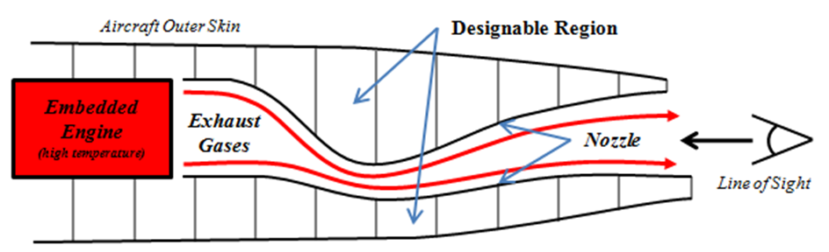

Figure 1. Notional cross section of a low observable exhaust structure configuration. Note the shape of the exhaust nozzle is driven by low observability constraints and all structural components are subjected to high temperatures. A designable region for the structural designer exists between the nozzle and the aircraft outer skins (gray lines). In this region, topology optimization is proposed to develop better structural layouts to manage the effects of thermal stresses and thermal expansion effects in the exhaust nozzle structure and surrounding substructure.

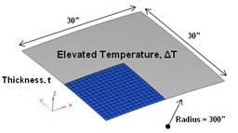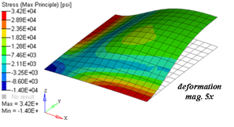

**(a) (b)**

Figure 3. (a) General curved shell structure whose behavior represents many hot structures including components from engine exhaust-washed structures (EEWS) and integrated thermal protection systems (TPS). Note boundary conditions are elastic. (b) Stress state for the quarter symmetric finite element model shown as blue in (a).

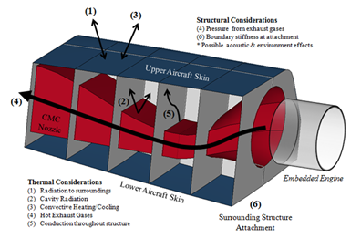

Figure 3. Full physics a notional engine exhaust-washed structure (EEWS) design space.

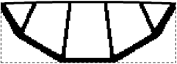

1. 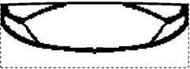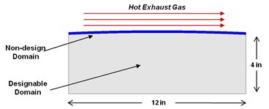**(b)**

Figure 7. (a) Simply exhaust-washed structure topology optimization design space. (b) Preliminary results of EEWS concepts developed via topology optimization for elevated temperature load. Work in this proposal will extend capabilities to include full physics heat transfer analysis to obtain more realistic temperature distributions as the structure evolves in optimization.

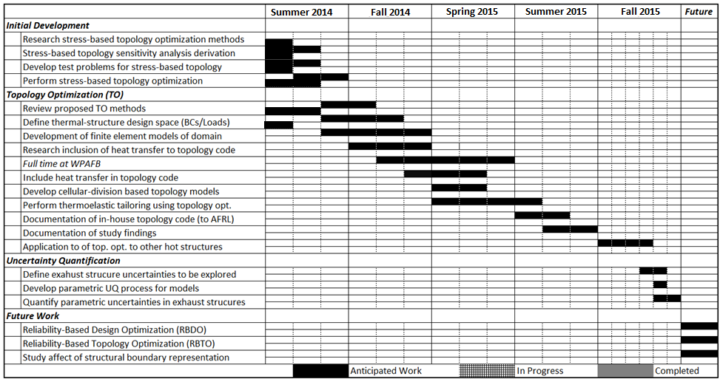

Figure 8. Gantt chart of the proposed work timeline for year one and preliminary work along with anticipated future tasks extending past year one.